RESELLRIGHTSMASTERY.COM

Private Label Rights License

Note: Please pass this license on to your customers whenever you are selling or giving away the Private Label Rights to this product.

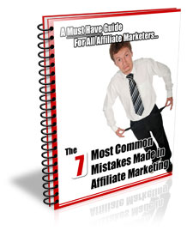
Product Title:
The 7 Most Common Mistakes Made in Affiliate Marketing

Private Label Rights:
No Restrictions Private Label Rights

Private Label Rights Terms & Conditions

[YES] Can be edited.
[YES] Can put your name as the author.
[YES] Can be broken down into articles.
[YES] Can be used as web or e-zine content.

[YES] Can be added into membership sites.
[YES] Can be sold in any format.
[YES] Can be packaged.
[YES] Can be offered as a bonus.
[YES] Can be given away for free (any format).
[YES] Can be sold on auction sites.

[YES] Can convey (Master) Resell Rights.
[YES] Can sell Private Label Rights.
[YES] Can be published offline.

In short, you can do literally anything you want with this product.

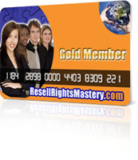
Bonus! Lifetime Membership Access to:

ResellRightsMastery.com ($197.00 Value!)

Gain lifetime access to a collection of TOP quality Resell Rights products, Private Label products, templates, auto responders, Advanced Reseller Strategies, and much more, as a Gold member!

=> Click here to sign up now!

